Name: ___________________________________ Period: ______________ Page: ______________

Evidence for Evolution Worksheet
Directions: Read each passage. Based on the reading, answer the questions using complete sentences. Scientists and crime solvers have something in common. They can both figure out what happened, even if no one was there to see it. They look for clues. The more clues that were left behind, the more likely they are to figure it out. If all of the clues point to the same conclusion, then they know what happened. Scientists have been gathering evidence for evolution for many years by looking at many different areas of science. Below are five areas of science that area discussed.
Paleontology shows us that organisms have changed gradually over time as reflected in the fossil record. Biogeography shows us how new species arise near the location of very similar species. Similar species share a common time and place. Developmental biology shows us that an organism builds on ancestral features as it develops from a single cell or embryo. Morphology shows us how organisms adapt ancestral features to new uses, even when there are more efficient solutions elsewhere in nature. Genetics shows us that we can group related species by the similarity of genes present in their genomes.
- What are the five areas of science mentioned that have evidence for evolution? _____________________ ____________________________________________________________________________________.
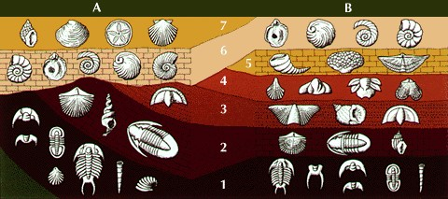
Paleontology - The Fossil Record Scientists use the age of fossils as evidence for evolution. Scientists can compare the older fossils of a species (or simila species) with younger fossils. This allows scientists to show how there have been changes in species (evolution) over time. There are two ways of dating fossils: Relative dating and absolute dating.
Relative dating uses a fossil’s location in rock layers to determine that fossil’s approximate age. Fossils found deeper in the ground are usually the oldest. Using the chart to the right, fossisl found in layer 1 are assumed to be older than a fossil found at layer 6, for example, by relative dating.
Absolute dating determines the fossil’s actual age in years by measuring amount of an element called carbon14 or Uranium 238 in the fossil. This is especially useful as it tells scientists how long the changes have taken to occur.
- What is Paleontology?

- How to fossils provide evidence for evolution (provide 2 reasons)?

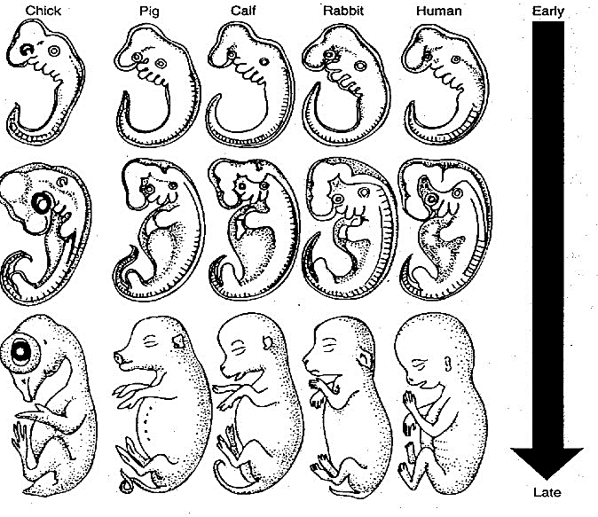
Developmental Biology - Embryology
Many scientists use what an organism looks like as an embryo, or embryology, as evidence for evolution. The embryos of most vertebrates look very similar and have similar structures. For example, fish, bird, rabbit, and human embryos are similar in appearance in early stages. They all have gill slits and a tail with muscles to move it. This suggests that all animals have a similar origon or ancient ancestor. Later as the embryos develop, they become less and less similar.
- What are Homologous structures?
4. How does the study of embryology provide evidence for evolution (provide 2 reasons)?

Morphology - Comparative Anatomy
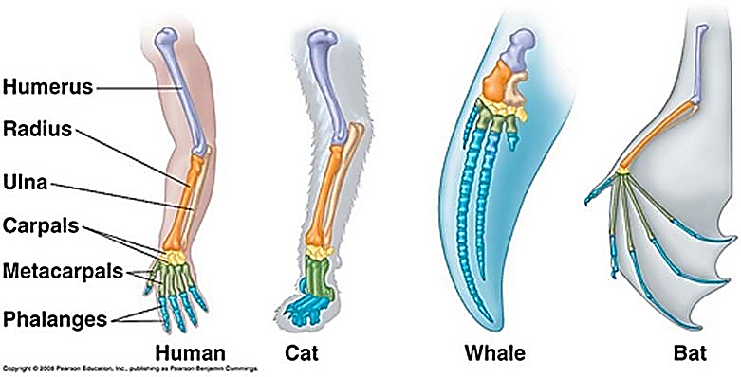
More evidence for evolution is offered by comparing the anatomy, or body parts, of different organisms. Many animals have body parts that are similar in both structure and function - these are called homologous structures. The forelimbs of animals like humans, whales, birds, and other creatures are strikingly similar even though the forelimbs are used for different purposes such as lifting objects, swimming, or flying. This suggests that the anatomy of animals is inherited from a common ancestor and evolved over time in different species. Thus the different changes in the forelimbs are adaptations to the needs of the organisms.

- What are Homologous structures? _________________________________________________________
- How does Morphology provide evidence for evolution (provide 2 reasons)?

Genetics - DNA Evidence
Scientists can now look at how similar the DNA is in two separate species. This can show how closely they are related. The human closest relatives, chimpanzees, share about 96% of the same DNA as us. Cows have about 80% of the same DNA, and Chcikens and Bananas both have abut 60% similarity (though not the same 60% obviously) The less alike organisms are the less similarity in their DNA, suggesting that evolution from a common ancestor occurred a very long time ago, but that very similar species share more recent common ancestors.

- What is DNA? _______________________________________________________________________

8. How does the study of genetics and DNA provide evidence of evolution?

